GDE405 Readings & Assignments: Week 2
Week 2 Reading
Complete the following reading early in the week:
- The online lectures for Week 2.
- The following chapters from the text, Drawing From Life by Clint Brown & Cheryl McLean:
  - Chapter 6: Foundations of the Human Structure
- The following pages from the book, Dynamic Figure Drawing by Burne Hogarth:
  - Chapter 1, pp. 9–43
  - Chapter 3, pp. 91–95
  - Chapter 4, pp. 120–133
  - Chapter 6, p. 152 and pp. 170–171
  - Chapter 7: Anatomy of the Limbs
  - Chapter 8: Heads and Portraits
Week 2 Assignments Overview
Assignment Summary: Week 2 | Due
Assignment 1: Anatomy Review—Skeleton | Tuesday, October 14, 2008
Assignment 2: Anatomy Review—Muscular System | Week 2, Day 4
Assignment 3: Hands and Feet | Thursday, October 16, 2008
Assignment 4: Drawing Heads and Portraits | Saturday, October 18, 2008
Remember that all assignment details can be found on the assignment pages located throughout the week. Go to those specific pages for direction on how to complete each individual assignment.

Week 2 Overview

Learning Outcomes:
- Develop an exaggerated, dynamic human character with correct anatomical reference.
- Review of the surface skeletal areas of the figure.
- Review of the surface muscular areas of the figure.
- Review the skeletal and muscular anatomy of the hands, feet, and head.
- Explore more varied positions and methods of depicting typical problem areas of the figure: heads, hands, feet.

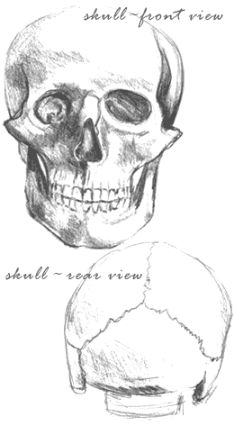
Anatomy Review—Skeleton
Now that you've had a review of basic life drawing techniques, it is important to also review some basic principles of anatomy. In order to draw the figure dynamically, it is necessary to have a comprehensive understanding and periodic review of the anatomy of the human form. To avoid a stiff, rigid, and tight drawing, exaggeration is one of the most important principles in life drawing to master. However, your knowledge of anatomy is key to this step in creating a dynamic figure drawing.
Artists have been rigorously studying human anatomy for centuries with the most celebrated periods being the Classical Greek in fifth century B.C. and the Renaissance. This study of anatomy may seem a tedious step, particularly if you've taken artistic anatomy before. However, the more you draw the underlying structure of the human form the better able you will be to stylize or depart from it. Artists who use the human form as a starting point always work extensively with the principles of anatomy in order to create more original work.
This review assumes the student has studied anatomy for artists in an in-depth manner previous to this course. This lesson primarily refers to the adult male and female. Infants and children have different proportions, namely larger heads in proportion to the size of the rest of their bodies. Infants and children until ages 4–5 also have more fat on their forms.
For the purposes of using certain anatomical points as a departure point in creating a dynamically drawn figure, a short review of important areas will be covered here. It is important for you to use anatomy books as a reference while going through these exercises.
The underlying structure of the body in life drawing is the skeletal and surface muscular points.
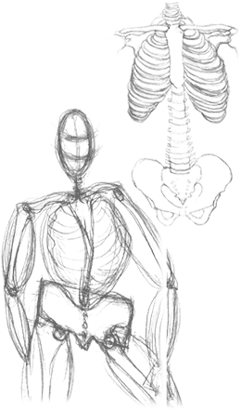
The skeleton provides the internal structure of the human form. Some key points to remember when representing the skeleton are:
- The spine is an S-curved shape, never a straight line. The seventh cervical vertebra appears in the back as a noticeable lump and indicates the beginning of the neck.
- The pelvis is a rectangular butterfly-shaped rigid structure that tilts front to back. This is particularly important when representing side views of the body. It is often angled, directly opposite to the direction of the shoulders, particularly in the contraposto position. There are two visible depressions in the back of the pelvis indicating the iliac spines and in the front indicating the iliac crest. These are handy points to indicate the direction of the pelvis.
- The ribcage is an oval shape and is usually a larger form than most students represent. The collarbone or clavicle in the front and scapula or shoulder blades in the back should be softly shaded areas and not over-represented by hard lines. They should also be placed accurately or the figure will be misshapen.
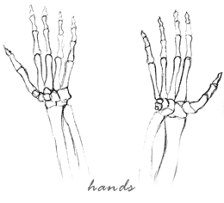
- The angle of the head is an oval and is usually posed opposite from that of the shoulders. The neck is a cylindrical form. The adam's apple or vertebra is only evident in some male forms.
- The legs have three bones and a kneecap. The entire form is a backward S-shape and not a straight line. The femur or thighbone angles in from the pelvis; the tibia and fibula each join at the patella (kneecap) and anklebone. The tibia or shinbone is often visible as it is right under the surface of the skin.
- The kneecap or patella is comprised of a separate rounded form and the tibial tuberosity that is part of the tibia. This forms the structure of the kneecap and should be represented as a substantial separate form of the mid-point of the leg. This is another form often misrepresented by the beginning figure student.
- The arms have three bones, including the elbow where the humerus meets the ulna. The humerus can only be seen at this elbow point. The lower part of the arm can twist and rotate.
- The anklebone is the lower end of the fibula and is on the outer side. The wrist is at the lower end of the ulna and is often seen throughout the length of the arm. It is always important to represent the wrists and ankles as they give weight to the body. The ankles and wrists are often wider than they may seem.
- The hands and feet are triangular in form, narrower at the heel/wrist and wider at the toes/fingers. Subsequent lectures in this week provide an in-depth study of these forms.

Anatomy Review—Muscular System

Muscular System
The muscles are responsible for most of the external visible forms in the body. The amount of fat on the figure is important to represent and will vary greatly from model to model, male to female. Women tend to acquire more weight on their hips, buttocks, and upper thighs. Men carry more of their bulk around the abdomen and upper body. In all body types except the obese, most key points of the skeleton and surface areas of the muscles are visible.
Surface Areas of the Muscles
- The back is by far the most complicated and misunderstood muscle area. There are three layers: the deepest layer forms two thick ropes of muscles that run down the spinal column, the middle layer consists of thin sheets, and the surface layer completes the familiar V-shape of the back.
- The front of the body has muscles that largely follow the form of the rib cage. The abdominal muscles consist of two bands of muscles that join the pubis to the rib cage.
- The muscles of the limbs work like cables. They attach to the bones near the joint at their smallest point, puff out at their largest, and join again at another bone. They are often involved in bending, straightening, and twisting the limbs. When the muscles are in movement or flexed, they are most visible.

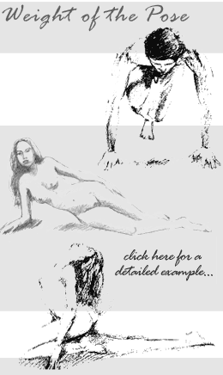
Dynamically Drawn Anatomically Accurate Figures
Dynamically drawn anatomically accurate figures can best be achieved when paying particular attention to the weight and movement of the body. By exaggerating the forms of the weight-bearing leg (such as the upper thigh, powerful kneecap, and ankle/foot) juxtaposed with a less specifically drawn non weight-bearing leg, you can start to understand how anatomy can work in dynamic figure drawing. It is the tension between the powerful and relaxed areas of the body that can create the most successful figure drawings. Do not depict all areas of the body the same. Use the following elements to create the tension in your drawing:
- The weight of the pose: one leg, seated, reclining. Depict this area with strong lines and confident shapes to show where the power of the pose lies. Consider using softer and less defined forms and shading on the relaxed areas. Never do the opposite, as the pose will appear off balance.
- The weight of the model. If you have a physically fit younger model, your drawing should look different than an older model with more weight on the frame. Women can also be easier to draw than men as their forms are more curved and easier to see.
- The gender of the model will also determine the location and mass of muscle.
- The pose itself: a standing pose is easier to exaggerate and depict than a seated or reclining pose. However, the seated or reclining poses can be more challenging and interesting to use the power vs. relaxed drawing approach.
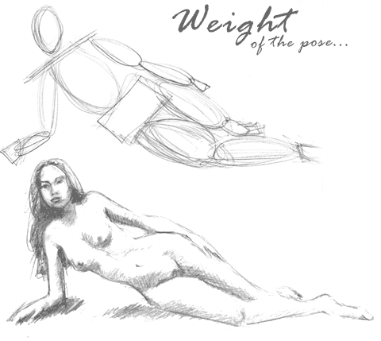

Hands
The hands and feet are two of the most difficult forms of the human body to draw. Students are often frustrated with trying to render their intricate systems accurately. However, they are unavoidable because they are the end points of the human body and are an extremely important part of any figure drawing. Like the features of the face, if a hand or foot is drawn inaccurately it can be spotted immediately. However, an understanding of anatomy and some practice should make it easier to depict and present them in a dynamically drawn figure.
The hands can add a very expressive form to any figure drawing. As in the features of the face, the pose of the hands will tell the viewer a great deal about what is happening in the drawing. Consider the difference in body language between an open and relaxed hand vs. a closed fist. They are one of the key conveyers of mood and character in dynamic figure drawing.

Skeletal System of the Hand
The skeletal system of the wrist and hand is divided into three sections of bones: the carpals (wrist), metacarpals (hand), and phalanges (fingers).
Carpals: there are eight carpal bones and they are cubed in form.
Metacarpals: there are five metacarpal bones and they are tubular in form. From the little finger towards the thumb they become gradually larger and form a united mass. The metacarpal bone of the thumb is shorter and thicker than the fingers. Both ends of the metacarpals are thicker. The joints of the metacarpals allow for a range of movement of the hand. The thumb, third and fourth metacarpal bones have a hinge joint that allows for greater flexibility and gripping of objects.
Phalanges: are the bones of the finger and thumb. The thumb has two phalanges and each finger has three. They get progressively smaller as the digits of the finger form the tip of the finger. The tip has a small point. The joint of these bones with the metacarpals form the knuckles of the hand. There is an inch of skin between the knuckle and the beginning of the bottom V of the fingers.

Muscular System of the Hand
The two largest muscles of the hand are the flexor of the thumb and the flexor of the little finger. There are also several tendons that make up the structure and allow for a range of movement of the hand and fingers.

Feet

The Skeletal System of the Feet
The bones of the feet consist of three sections: the tarsus, the metatarsus, and the phalanges.
Tarsus: is comprised of seven bones that are bigger than the carpal bones of the wrist since they bear the weight of the entire body. The upper bone of the tarsus is the talus that articulates with the leg. The calcaneum is the bone of the heel and is the largest bone of the tarsus. The other bones of the foot are the three cuneiform bones, the cuboid, and the navicular bone.
Metatarsals: have five shaft bones with the thickest being the form of the largest toe. The longest is the next bone and the smallest is the littlest toe.
Phalanges: similar to the hand, are five in number. The largest is the phalanges of the big toe. The big toe has only two phalanges, whereas the other toes have three phalanges.
Muscular System of the Feet
There are two sets of muscles of the foot: the dorsal and the plantar.

Drawing the Feet
The feet are an entirely different structure than the hands. However, many of the same problems can occur when trying to draw them. Because the weight of the entire body is carried by the feet it is important to give this form enough size and definition. As with the hands, try to capture the overall form, then draw the details later. Observe the arch, the sloping plane of the top of the feet, the bones of the ankle joints, and the considerable size of the heel.
[PDF - drawing feet.]

Heads

The Head
The head is another complicated and frustrating form to represent. It can be relatively easy to create a straight-on view of a generic face with linear forms; however, it can often look cartoon-like and expressionless. Depicting a particular expression or achieving a likeness can be very difficult. The more types of faces you can draw, the better able you will be to achieve both. However, do not expect to do so in a short period of time. In addition, some artists are better able to depict the figure rather than a portrait and vice versa. The goal of a dynamically represented figure is to create an accurate depiction of the head close to your model, not a full likeness. In order to create fully rendered portraits, a separate course in portraiture is advised.

The Skeleton of the Head
The uniqueness of an individual lies largely in the structure of the skull. Unlike most other bones in the body, the skull is not covered by large amounts of muscle and tissue. Therefore, knowledge of the skull is essential in depicting a portrait. The skull is comprised of 22 bones, eight of which make up the cranium. The other 14 bones are the forms in the face and jaw. Their sizes and shapes vary widely from gender to race.
Some key points to remember in the skeletal form of the head:
- The jaw is the only moving part of the face. The rest of the bones form a unified, fused structure.
- The biggest form of the skull is the cranium, which is depicted as an oval. The facial area is relatively small.
- The eyes are represented in the skull as orbital cavities.
- The nose and ears are largely comprised of cartilage, not bone.
- The facial area is relatively flat and makes a sharp turn at the side of the face.

The Muscles of the Head
- There are two main muscles that encircle the eye.
- There is another circular muscle that encircles the lips.
- There are muscles that open and close the mouth and give expression to the lips that are webbed from the circular mouth muscle.
- There is a flat sheath of muscle along the forehead and on the side of the head.
- There are shorter, wider muscles that make up the chin.

Drawing the Head
The location of the features of the face can be deceiving. It is easy to draw the face too long, the lips too small, and the nose almost double its usual size with pig-like snouts. The eyes are often placed too high on the head. Drawing a portrait is an exercise in concentration, patience, and observation as it is a complicated form that requires a subtle approach to depict accurately. Take your time and observe the features and forms.
[PDF – Drawing Heads]

Assignment 1: Anatomy Review—Skeleton
Using your graphite tools, draw a front/back/side view of the standing figure in skeletal form. Keep the skeleton in the correct proportions learned in Week 1. You should represent the ribcage, spine, hands, and feet in a detailed form. Label all key surface areas. You will be graded on the proportion, balance, and accuracy of the anatomy.
Scan or shoot the drawing with a digital camera and save the image as a jpeg file. By Tuesday, October 14, 2008, submit the jpeg file to the Discussion Area.
Review and critique the work of at least two other students early in the week. Post your comments by responding to the thread below. You can ask questions or respond generally to the overall experience. Always be honest, clear, and concise, using constructive language, even in criticism, to work toward the goal of positive progress.
Grading Criteria: | Maximum Points
Proportion and balance in drawing. | 4
Accuracy of the anatomy. | 4
Assignment submission on time. | 1
Participation in discussion with concise and clear comments. | 3
Total: | 12
For assistance with any problems you may have when completing this assignment—OR—to offer your assistance to classmates, please use the Problems and Solutions Discussion area located through the left side navigation link.
Remember the relations of proportions from the lecture.

Assignment 2: Anatomy Review—Muscular System
Part 1:
Using your graphite tools, draw a front/back view of the standing figure in muscular form. Label all surface areas. Scan or shoot the drawings with a digital camera and save the image as a jpeg file. By Thursday, October 16, 2008, submit the files to the appropriate topic in this Discussion Area.
Part 2:
After you post the drawings, respond to the following question. By Thursday, October 16, 2008, post your response to the appropriate topic in this Discussion Area. Review and critique the responses of at least two other students early in the week.
- Discuss your past experience with artistic anatomy. What are your perceived problem areas in drawing the figure? What are your strengths?
Grading Criteria: | Maximum Points
Drawing had proportion and balance. | 4
Anatomy was accurate. | 4
Drawings submitted on time. | 4
Participated in the discussion with concise and clear comments. | 4
Student used terminology and relates concepts introduced in course studies throughout discussion contributions. | 4
Total: | 20
For assistance with any problems you may have when completing this assignment—OR—to offer your assistance to classmates, please use the Problems and Solutions Discussion area located through the left side navigation link.
Part 1: Make this a medical illustration!
- Discuss your past experience with artistic anatomy. What are your perceived problem areas in drawing the figure? What are your strengths?

Assignment 3: Hands and Feet
Review pp. 37–43, 120–126 and 132–133 in Dynamic Figure Drawing by Burne Hogarth
Part 1: Drawing Various Poses of Hands
Draw your or your model's hands in several exaggerated poses using various different tools:
- Fingers splayed apart: charcoal tools.
- Closed fist: graphite tools.
- Thumb touching fingers: conté crayon.
- Pose of your choice: medium of your choice.
Scan or shoot the drawing with a digital camera and save the image as a jpeg file. Also share the amount of time you took to complete the drawings. By Thursday, October 16, 2008, submit the image to the appropriate topic in this Discussion Area.
Part 2 : Drawing Various Poses of Feet
Draw your or your model's feet in several exaggerated poses by using various tools:
- Toes pointed: graphite tools.
- Bottom of foot: charcoal tools.
- Crossed feet: conté crayon.
- Pose of your choice: medium of your choice.
Scan or shoot the drawing with a digital camera and save the image as a jpeg file. Also share the amount of time you took to complete the drawings. By Thursday, October 16, 2008, submit the file to the appropriate topic in this Discussion Area.
Part 3: Discussion
After posting the drawings for these assignments respond to the following questions. Post your responses to appropriate topic in this Discussion Area by Thursday, October 16, 2008.
- What is your comfort level in drawing hands and feet? What have you learned to help you and your peers with these parts of the body?
- The facilitator has assigned you a peer's hands/feet drawing to critique. Discuss at least three positive techniques and three areas for improvement in the drawing by the end of the week.

\
Grading Criteria: | Maximum Points
Form is accurate. | 4
All surface areas are correctly labeled. | 4
Student submits assignment on time. | 4
The poses of hands are drawn correctly. | 4
The poses of feet are drawn correctly. | 4
Participates in the discussion with concise and clear comments. | 4
Student uses terminology and relates concepts introduced in course studies throughout discussion contributions. | 4
Total: | 28
For assistance with any problems you may have when completing this assignment—OR—to offer your assistance to classmates, please use the Problems and Solutions Discussion area located through the left side navigation link.
Part 1: Various poses of the hand: Be sure you follow the guidelines concerning medium and pose.
Part 2: Various poses of the feet
Part 3:Discussion

- What is your comfort level in drawing hands and feet? What have you learned to help you and your peers with these parts of the body?
- The facilitator has assigned you a peer's hands/feet drawing to critique. Discuss at least three positive techniques and three areas for improvement in the drawing by the end of the week.

- My comfort level in drawing hands and feet I would rate about 6 out of 10. I think there’s still a bit of practice to go in terms of portraying them without error, but I’m more than comfortable drawing them now and am pretty confident I can draw a hand or a foot, provided I still have some reference. To not use reference is a major goal. I’ve learned that using the 4-step process on the hand just as in the body is essential and drawing an underlying skeleton of line and geometrical parts makes it way easier than just trying to contour draw it by trial and error.

Assignment 4: Drawing Heads and Portraits
Part 1: Portraits
Draw two portraits:
- Self-portrait 3/4 view with some type of facial expression (smile, frown, anger, etc.) using graphite tools.
- A portrait with the head tilted back or forward in a foreshortened view by using charcoal tools.
Review pp. 10–11, 91–95, 152 and 170–171 in Dynamic Figure Drawing by Burne Hogarth
Scan or shoot the portraits with a digital camera and save them as a jpeg file. By Saturday, October 18, 2008, submit the files to the appropriate topic in this Discussion Area.
Part 2: Discussion
After posting the drawings for these assignments respond to the following questions. Post your responses to the appropriate topic in this Discussion Area by Saturday, October 18, 2008.
- What is your experience drawing heads/portraits? Do you find them easier or harder than the figure itself?
- The facilitator has assigned you a peer's portrait drawing to critique. Discuss at least three positive techniques and three areas for improvement in the drawing by the end of the week.
Review and critique the work of at least two other students. Post your comments by responding to the appropriate thread. You can ask questions or respond generally to the overall experience. Always be honest, clear, and concise, using constructive language, even in criticism, to work toward the goal of positive progress.
Grading Criteria: | Maximum Points
Accuracy of form in the drawings. | 4
Aesthetics of the drawings. | 4
Completion of the drawing with all the specifications. | 4
Amount of time taken to complete drawing and assignment submitted on time. | 4
Participation in discussion with concise and clear comments. | 4
Use of terminology and related concepts throughout discussion contributions. | 4
Total: | 24
For assistance with any problems you may have when completing this assignment—OR—to offer your assistance to classmates, please use the Problems and Solutions Discussion area located through the left side navigation link.
Part 1: portraits - Place close attention to feature placement.
Part 2:Discussion

